**May 16 Home questions**

#1. WAP to create a new data type DATE with the help of structure and

typedef. Write the following user defined functions for the date manipulations.

a) To return next date

b) To return next month.

c) To return next year.

d) to add few days in a date.

e) To add few months in a date.

f) To add few years in a date.

g) To return month name from a date.

h) To display date in various format such as DD-MM-YYYY, DD.MM.YY

Code:

#include <stdio.h>

void next(int date_285, int month_285, int year_285)

{

    printf("Next day is=> ");

    if(date_285+1>30)

    printf(" 01|%d|%d\n",month_285+1,year_285);

    else

    printf(" %d|%d|%d\n",date_285+1,month_285,year_285);

}

void nextmonth(int month)

{

    printf("Next month is=>");

    if(month+1>12)

    printf(" September\n");

    else

    printf(" %d\n", month+1);

}

void nextyear(int year)

{

    printf("Next month is=>");

    printf(" %d\n", year+1);

}

void add_days(int date, int month, int year)

{

    int n;

    printf("How many days do u want to add?\n");

    scanf("%d",&n);

    if(date+n>30)

    printf(" 01|%d|%d\n",month+1,year);

    else

    printf(" %d|%d|%d\n",date+n,month,year);

}

void month_name(int month)

{

    if(month==1)

    printf("The month is January\n");

    if(month==2)

    printf("The month is February\n");

    if(month==3)

    printf("The month is March\n");

    if(month==4)

    printf("The month is April\n");

    if(month==5)

    printf("The month is May\n");

    if(month==6)

    printf("The month is June\n");

    if(month==7)

    printf("The month is July\n");

    if(month==8)

    printf("The month is August\n");

    if(month==9)

    printf("The month is September\n");

    if(month==10)

    printf("The month is October\n");

    if(month==11)

    printf("The month is November\n");

    if(month==12)

    printf("The month is December\n");

}

typedef struct DATE{

    int date;

    int month;

    int year;

}DATE;

int main()

{

    DATE d1;

    int i,j;

    printf("Please provide the date, month and year respectively\n");

    scanf("%d%d%d", &d1.date,&d1.month,&d1.year);

    next(d1.date,d1.month,d1.year);

    printf("\n\n");

    nextmonth(d1.month);

    printf("\n\n");

    nextyear(d1.year);

    printf("\n\n");

    add_days(d1.date,d1.month,d1.year);

    printf("\n\n");

    month_name(d1.month);

    printf("\n\n");

}

Output:

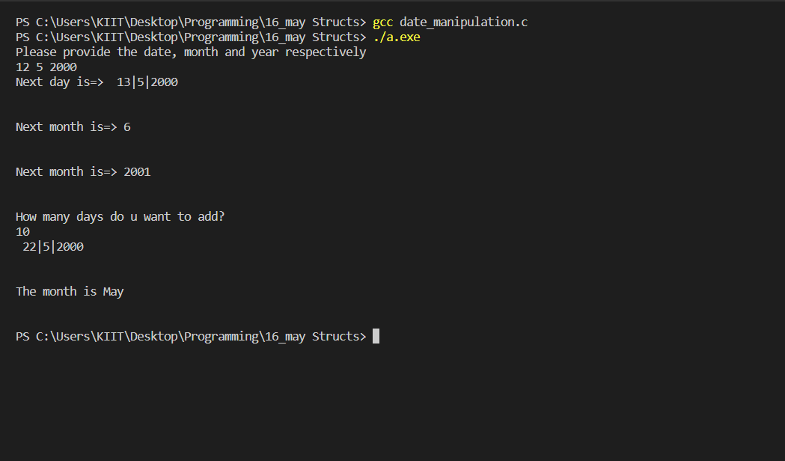

#2. WAP to calculate the difference between two time periods. Times

are given in hr, min and sec.

Code:

#include <stdio.h>

typedef struct time{

    int hour;

    int minute;

    int second;

}time;

int main()

{

    time t1_285,t2_285,t3_285;

    int h1,h2,h3,m1,m2,m3,s1,s2,s3;

    printf("Please give the first timing in hour/minutes/second format\n");

    scanf("%d%d%d",&h1,&m1,&s1);

    printf("Please give the second timing in hour/minutes/second format\n");

    scanf("%d%d%d",&h2,&m2,&s2);

    t1_285.hour=h1;

    t1_285.minute=m1;

    t1_285.second=s1;

    t2_285.hour=h2;

    t2_285.minute=m2;

    t2_285.second=s2;

    t3_285.hour= t1_285.hour-t2_285.hour;

    t3_285.minute=t1_285.minute-t2_285.minute;

    t3_285.second=t1_285.second-t2_285.second;

    if(t3_285.second<0)

    {

        t3_285.second=-1*(t3_285.second);

    }

    if(t3_285.minute<0)

    {

        t3_285.minute=-1*(t3_285.minute);

    }

    if(t3_285.hour<0)

    {

        t3_285.hour=-1*(t3_285.hour);

    }

    printf("The difference of your two timing is %d hours %d minues and %d seconds\n",t3_285.hour,t3_285.minute,t3_285.second);

    return 0;

}

Output:

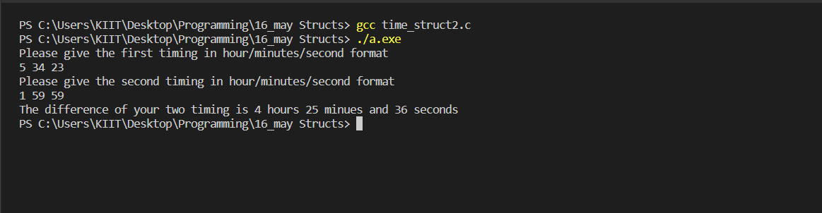

#3. WAP to extract individual bytes from an unsigned int using union.

Code:

#include<stdio.h>

union tagname_285

{

    unsigned int a;

    unsigned char s[4];

};

union tagname_285 object_285;

int main()

{

    char i;

    object_285.a=0xAABBCCDD;

    printf("Integer number: %ld, hex: %X\n",object_285.a,object_285.a);

    printf("Indivisual bytes: ");

    for(i=3;i>=0;i--)

        printf("%02X ",object_285.s[i]);

    printf("\n");

    return 0;

}

Output:

